E-BIZ USER GUIDE
<< EBIZ My Booking Favorite Register >>
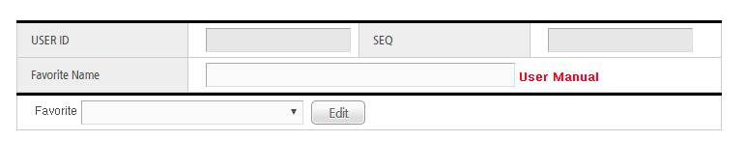
①
②
*.Favorite Info
1. When user save favorite item, “Favorite Name” is necessary item
2. When user other favorite item, after selecting item in list box,
User can edit pressing “Edit” button

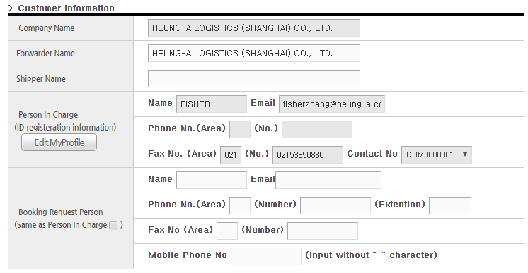
①
*.Customer Info
1. Booking Request Person:
When user input “Booking Request Person”, If it’s same with login user info, check “Same as Person In Charge” check box

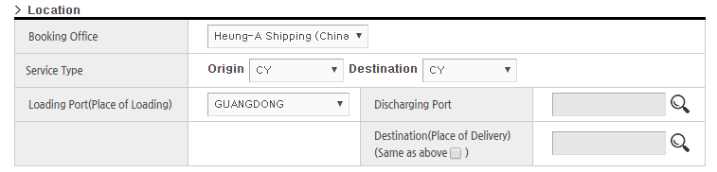
①
②
③
④
⑤
*. Location & Schedule
1. Booking Office : select Booking office
2. Service type: select Loading, Discharging Term
3. Loading Port: select Loading Port
4. Discharging Port: select Discharging Port
(use reading glasses icon)
5. Destination Port: select Destination Port
(use reading glasses icon)
.

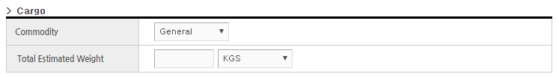
①
②
*.Cargo Info
1. Select Commodity.
2. Input total estimated weight

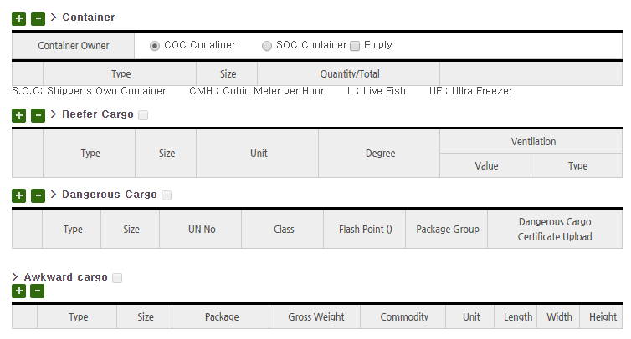
①
②
④
③
*. Container Info
1. Container: register container info( user can select COC/SOC)
2. Reefer Cargo: If cargo is reefer cargo, register reefer
container info
(When user register reefer container, user have to
Register “Container” and “Reefer Cargo” separately)
3. Dangerous Cargo: If cargo is Dangerous cargo,
register dangerous cargo
(When user register Dangerous container, user have to
Register “Container” and “Dangerous Cargo” separately)
4. Awkward Cargo: If cargo is Awkward cargo, register awkward
Container info
(When user register awkward container, user have to
Register “Container” and “Awkward Cargo” separately)
-.When user add container or remove container,
use “+” or “-“ button

Example1) registering general Container

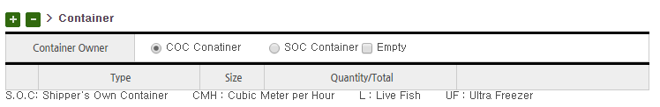
①
*1.after selecting COC/SOC, input container quantity
( If cargo is empty CNTR, check “Empty”)

Example2) registering Reefer Container

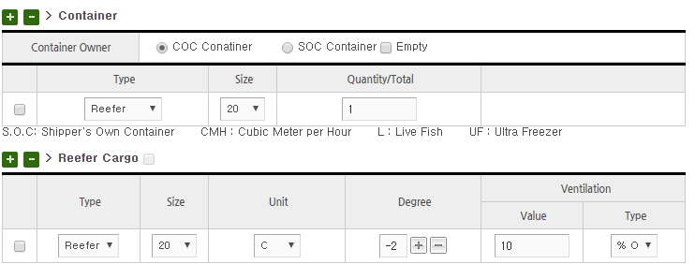
①

*. When user register Reefer container,
User have to register “Container” and “Reefer Cargo”
separately

*1.Ventiation Type: User can select
“%Open(percent)” or CHM(CM)”
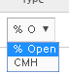

Example) Registering Dangerous Container
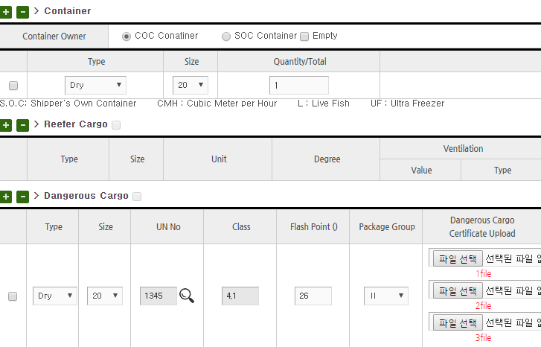
①
②
③

*. When user register dangerous container,
User have to register “Container” and “Dangerous Cargo”
separately

*1. User can Search UN No with reading glasses icon
*2. Register Flash Point
*3. User can register DG image

Example4) Registering Awkward Container
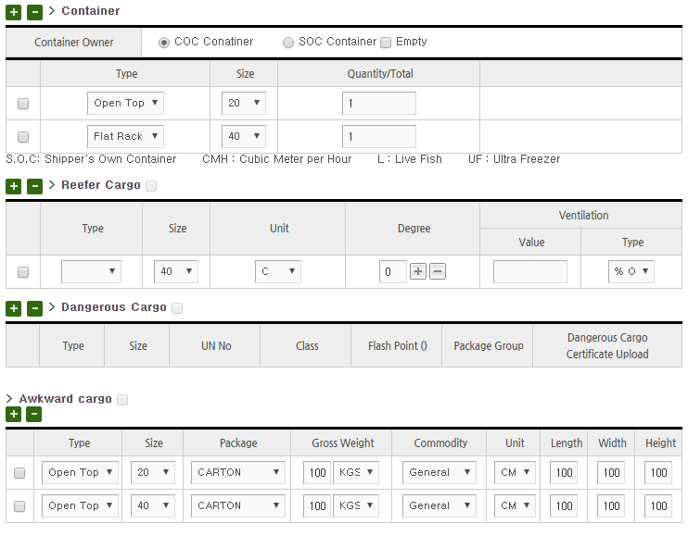

*.When user register awkward container,
“Container” and “Awkward cargo” separately

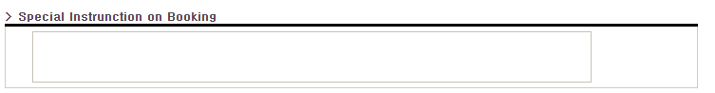
*.Additional Instruction
-. User can input special instruction on booking
①
②
*. Save Option
1. Init : All item will be clear
2. Favoirte Save : User can save inputting booking info
as Favorite

-End-

