<< EBIZ WEB BOOKING FAVORITE RETRIEVE >>

*.This web page is for retrieving or updating Booking favorite

-.Main screen shoot

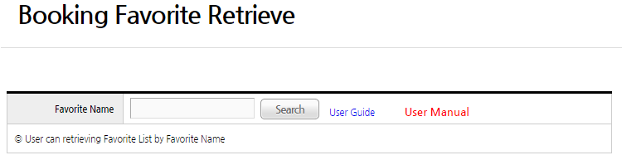
-.1) After inputting query option, user can retrieve data
-.2) If user wan to detail view, press text at “Favorite Name”.
And then, will show detail page
-.3) use “DELETE” button if user want to delete B/L Favorite after checking
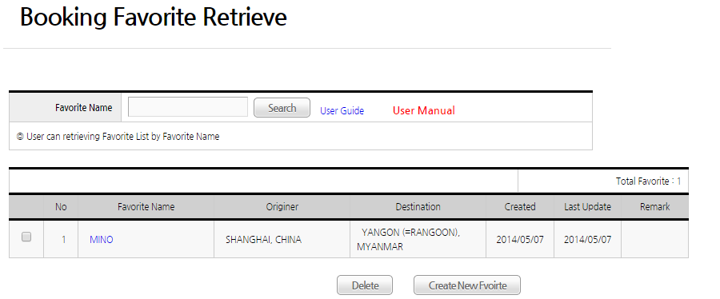

-.Detail page screen shoot
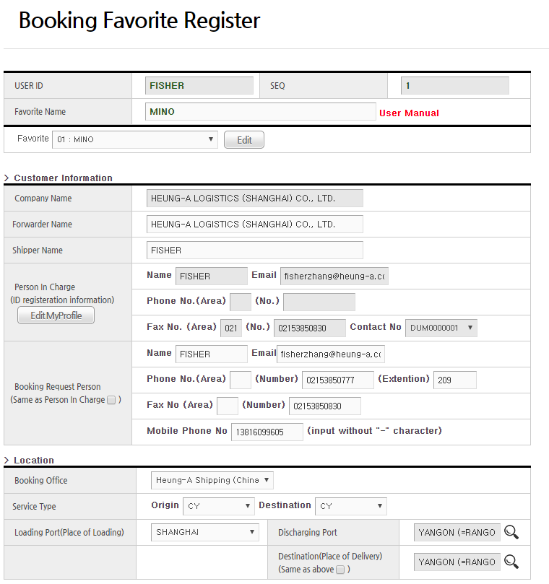

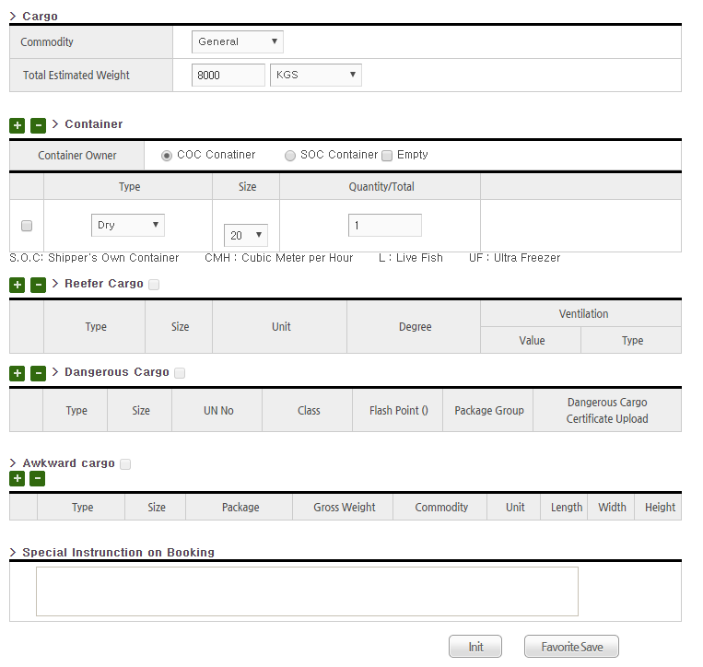

*.To use this webpage, user need to change internet explore option
in MenuBar -> Tools -> Compatibility View Settings
1) Add "heung-a.com" ( press "Add" button )
2)Check checkbox "Dispaly all websites in Compatibility view"
3)Press “Close” button

