E-BIZ USER GUIDE
<< Booking Register>>
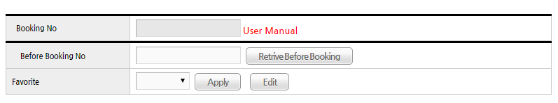
①
②
③

*. Booking Info
1. Booking No: After saving data, Booking No will be created.
2. Before Booking No: After inputting before booking no, user can
Search pressing “Retrieve Before Booking” button
3. Favorite: User can apply favorite list
(After selecting item in favorite list box, user can
Apply favorite item or can edit favorite item)
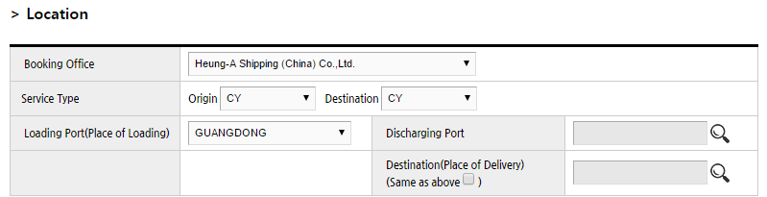
①
②
③
④
⑤
⑥
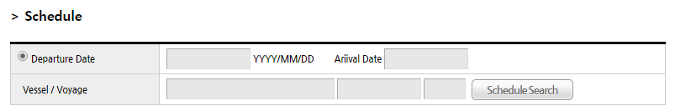
*. Location & Schedule
1. Booking Office : select Booking office
2. Service type: select Loading, Discharging Term
3. Loading Port: select Loading Port
4. Discharging Port: select Discharging Port
(use reading glasses icon)
5. Destination Port: select Destination Port
(use reading glasses icon)
6. Schedule Search : After inputting Loading Port/Discharging Port,
User can search Vessel/Voyage

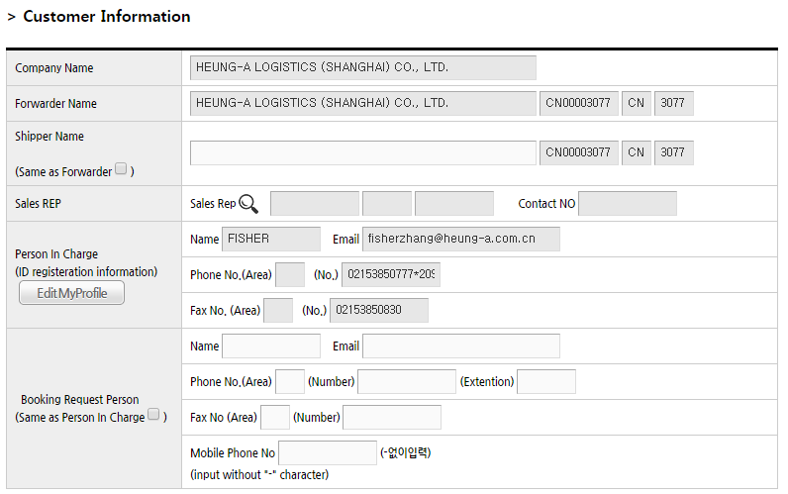
①
*.Customer Info
1. Booking Request Person:
When user input “Booking Request Person”, If it’s same with login user info, check “Same as Person In Charge” check box

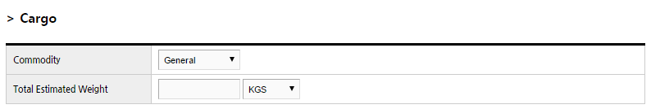
①
②

*. Cargo Info
1. Select Commodity.
2. Input total estimated weight

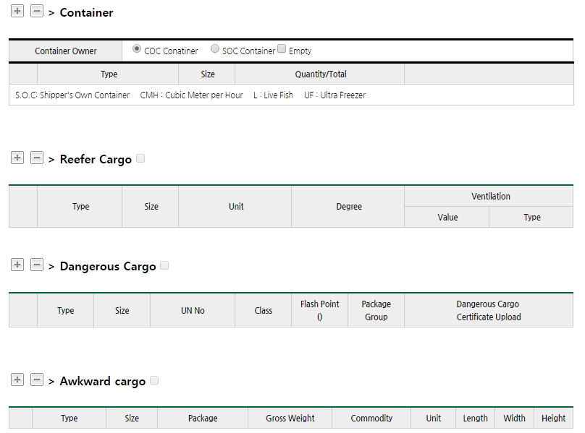
*. Container Info
①
②
④
③
1. Container: register container info( user can select COC/SOC)
If cargo is empty CNTR, user have to check “empty”
2. Reefer Cargo: If cargo is reefer cargo, register reefer
container info
(When user register reefer container, user have to
Register “Container” and “Reefer Cargo” separately)
3. Dangerous Cargo: If cargo is Dangerous cargo,
register dangerous cargo
(When user register Dangerous container, user have to
Register “Container” and “Dangerous Cargo” separately)
4. Awkward Cargo: If cargo is Awkward cargo, register awkward
Container info
(When user register awkward container, user have to
Register “Container” and “Awkward Cargo” separately)
-.When user add container or remove container,
use “+” or “-“ button


Example1) registering general Container
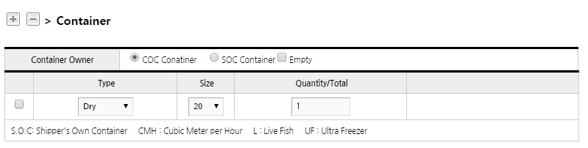
*1.after selecting COC/SOC, input container quantity
①

Example2) registering Reefer Container
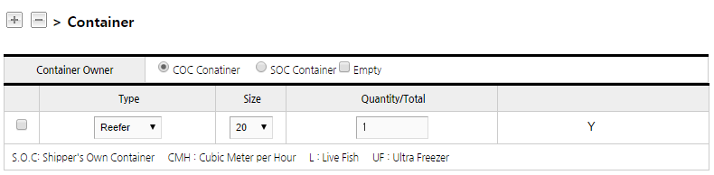
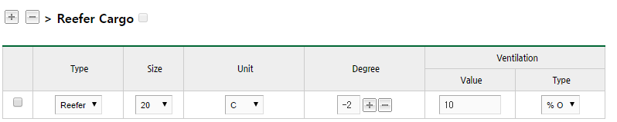
①

*. When user register Reefer container,
User have to register “Container” and “Reefer Cargo”
separately

*1.Ventiation Type: User can select
“%Open(percent)” or CHM(CM)”
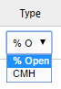

Example3) Registering Dangerous Container
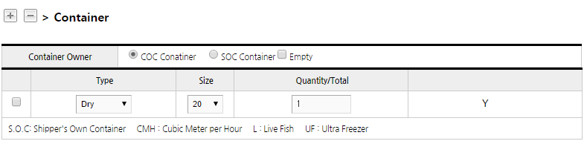
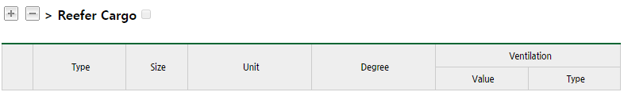
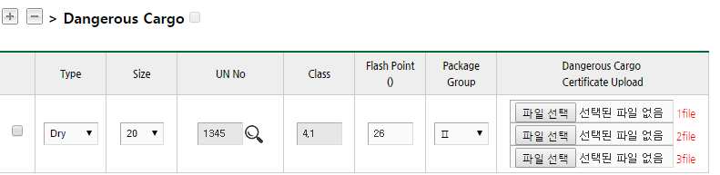
①
②
③

*. When user register dangerous container,
User have to register “Container” and “Dangerous Cargo”
separately

*1. User can Search UN No with reading glasses icon
*2. Register Flash Point
*3. User can register DG image

Example4) Registering Awkward Container
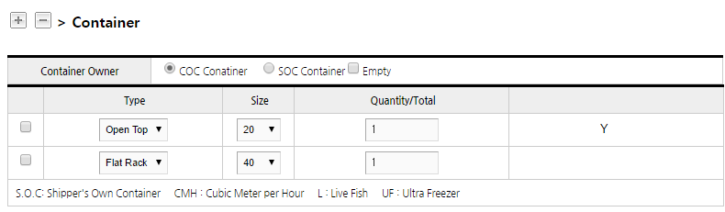
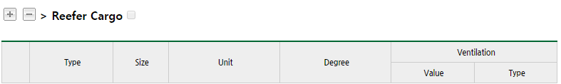
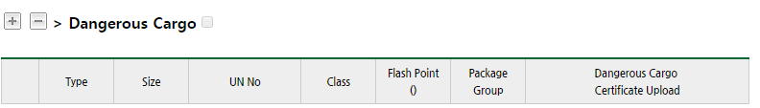
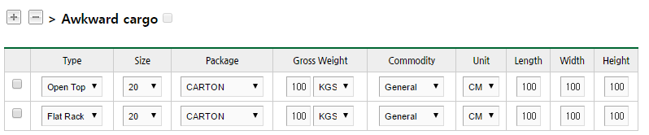

*.When user register awkward container,
“Container” and “Awkward cargo” separately

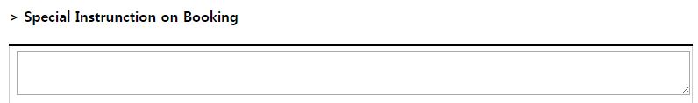
*.Additional Instruction
-. User can input special instruction on booking

*.

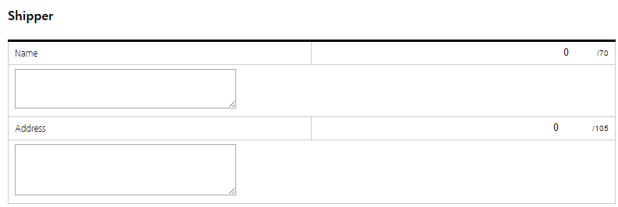
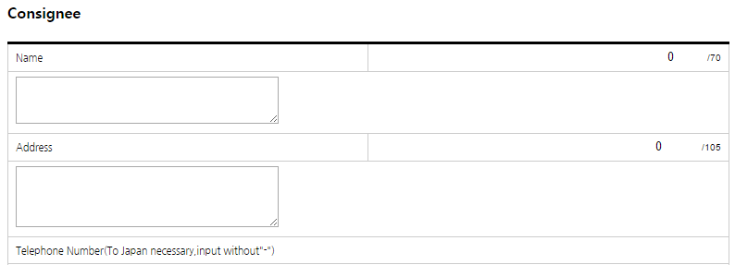
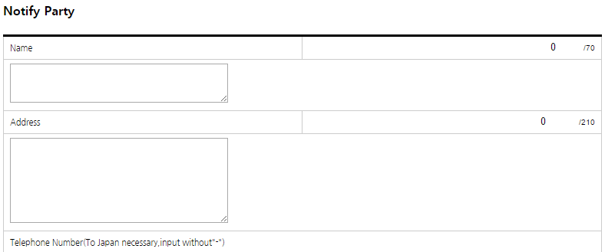
*.SHIPPER/CONSIGNEE/NOTFIY
-.Case Chinese User, It’s necessary SHIPPER/CONSIGNEE/NOTIFY info

*.Closing info
-.user can check out Document/Cargo closing info
①
②
③

*.Save Option
1. Init: All item will be clear
2. Submit: If user push this button, save booking info
Booking will be requested to Heung-a PIC
3. Favorite Save: User can save inputting
booking info as Favorite

-End-

