E-BIZ USER GUIDE
<< EBIZ BOOKING STAUS >>

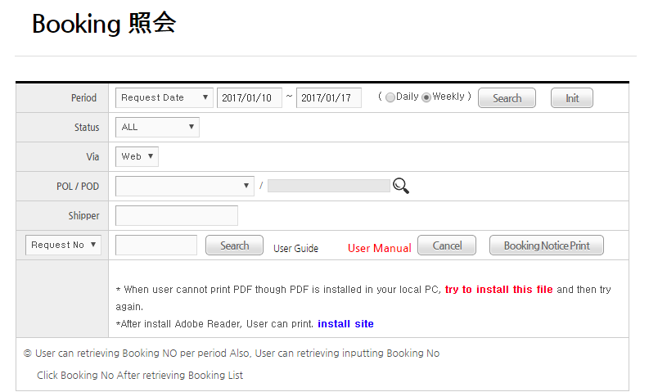
①
②
④
⑤
③
⑥
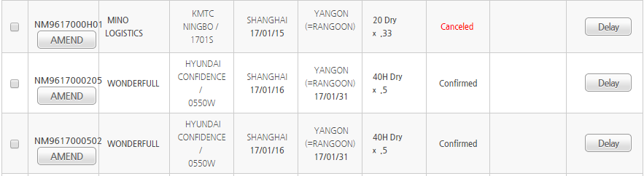
⑧
⑦
1. Period: User can search after inputting booking period
2. Status
-.Processing: It is status that Heung-a PIC doesn’t check booking
-.Booked: It is status that Heung-a PIC confirm booking
-.Rejected: It is status that Heung-a PIC reject booking
-.Canceled: It is canceled status
-.Specail Not Approved : It is status that Specail CNTR is not approved
(Danger/Reefer/Awkward booking need approval separately)
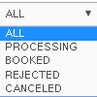
3. Via: It mean by Booking route
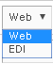
4. No option: User can use “Request No” or “Booking No”
as search option
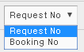
5. Request No, Booking No : Request no is same with Booking No
6. Check Box: When user print “Booking Confirm Print”, it is used
7. Booking Confirm Print: After checking check box that user want
to print, user can print “Booking Confirm Print ”button
8. Delay Notice: If booking info is delay, “Delay Notice” button
Will be displayed. Pressing “Delay Notice” button,
User can print “Delay Notice”
-End-

